Education of Homeless Children and Youth/Fanau i Nofoaga le Tumau Program   
 Mini-Manual



American Samoa Department of Education

Education of Homeless Children & Youth/Nofoaga le Tumau Program

Liza Maria Tuatoo

EHCY/NOFOAGA LE TUMAU PROGRAM COORDINATOR

684-633-2220

ASDOE MAIN OFFICE

UTULEI

WWW.DOE.AS

UPDATED 2/1/2024

EHCY/Nofoaga le Tumau Mini-Manual

All resources mentioned in this manual can be found on the American Samoa EHCY/Nofoaga le Tumau Program website  
website address

Table of Contents

Glossary of Acronyms & Abbreviations 4

McKinney-Vento/Homeless Education Information 4

Purpose 4

Definition 5

Student Rights 6

STEP 1: Outreach & Identification 7

Strategies to Increase Identification 7

STEP 2: Verification & Eligibility 10

Verification/Confirming Eligibility - 10

Eligibility Notification - 11

Parent Communication - 13

STEP 3: Planning & Delivery of Services 15

Needs Assessment 15

STEP 4: Records & Reporting Processes 17

Data Collection & Reporting Tools 17

Coding in Student Management System 17

Student MV File & Permanent Records File 18

IDCI/Program Contact File 18

ISEE Uploads 19

Funding & Fiscal Responsibilities 20

Funding Options 20

Accounting processes 20

McKinney-Vento Liaison 21

District MV Policy 22

Program Evaluation & Monitoring 22

Annual Self-Assessment for Program Improvement 22

Monitoring by the American Samoa Department of Education 22

# Glossary of Acronyms & Abreviations

| Acronym | Program, etc. |
| --- | --- |
| MVA | McKinney-Vento Act |
| EHCY | Education of Homeless Children and Youth |
| ESSA | Every Student Succeed Act – the 2018 reauthorization of the Elementary and Secondary Education Act of 1965 |
| ESEA | Elementary and Secondary Education Act |
| SEA/LEA | Unified State & Local Educational Agency |
| ASDOE | American Samoa Department of Education |
| ED | United States Department of Education |
| UHY | Unaccompanied Homeless Youth |
| ASDOECI | American Samoa DOE EHCY Contact Information (program contacts directory) |
| IDEA | Individuals with Disabilities Education Act (Special Education) |
| FAFSA | Free Application for Federal Student Aid |
| PII | Personally Identifiable Information |
| UHS | Unstably Housed Student |
| UY | Unaccompanied Youth |

# EHCY/Nofoaga le Tumau Program Purpose and Definitions

## Purpose

Subtitle VII-B of the McKinney-Vento Homeless Assistance Act (MVA) authorized the federal Education for Homeless children and Youth (EHCY) program along with the Title IX-A section of Every Student Succeeds Act (ESSA) to provide students experiencing homeless with protections and services to ensure they enroll and attend school, complete their high school education and prepare for college or careers – their best hope of avoiding poverty and homelessness as adults.

It ensures students who lack a fixed and regular nighttime residence are provided equal access to a free appropriate public education-including public preschool, are able to stay in their school of origin, receive free school meals, and barriers are removed so they may fully participate in their education.

The ASDOE works as a unified SEA/LEA to ensure that the rights and services guaranteed by the MVA are implemented throughout the territory**.**

***All public-school must follow the requirements of the MVA, whether or not they receive a McKinney-Vento supplemental subgrant or receive other federal funds.***

Definition  
The ASDOE refers to students meeting the eligibility requirements of the MVA as “Unstably Housed Students” (UHS) in place of “homeless children and youths” to reflect more culturally appropriate language.

Subtitle VII-B of the McKinney-Vento Homeless Assistance Act (per Title IX, Part A of the Elementary and Secondary Education Act, as amended by the Every Student Succeeds Act) defines *homelessness* and provides protections under the federal law, as follows:   
The term "homeless children and youths":  
(A) means individuals who lack a fixed, regular, and adequate nighttime residence; and  
  
(B) includes:

(i) children and youths who are sharing the housing of other persons due to loss of housing, economic hardship, or a similar reason; are living in motels, hotels, trailer parks, or camping grounds due to the lack of alternative adequate accommodations; are living in emergency or transitional shelters; or are abandoned in hospitals;*   
(ii) children and youths who have a primary nighttime residence that is a public or private place not designed for or ordinarily used as a regular sleeping accommodation for human beings;  
(iii) children and youths who are living in cars, parks, public spaces, abandoned buildings, substandard housing**, bus or train stations, or similar settings; and   
(iv) migratory children (as such term is defined in section 1309 of the Elementary and Secondary Education Act of 1965) who qualify as homeless for the purposes of this subtitle because the children are living in circumstances described in clauses (i) through (iii);

(v) unaccompanied youth (UY) who meet the homeless living situations listed above AND are “not in the physical custody of parent or guardian”.

*Per Title IX, Part A of the Every Student Succeeds Act, "awaiting foster care placement" was removed from the definition of homeless on December 10, 2016.

**Per Title 24 – Housing and Urban Development – Federal Preference: Substandard Housing Section 5.425  
A unit is substandard if it:  
(1) Is dilapidated; (The unit does not provide safe and adequate shelter, and in its present condition endangers the health, safety, or well-being of a family; or the unit has one or more critical defects, or a combination of intermediate defects in sufficient number or extent to require considerable repair or rebuilding. The defects may involve original construction, or they may result from continued neglect or lack of repair or from serious damage to the structure.)  
(2) Does not have operable indoor plumbing;  
(3) Does not have a usable flush toilet inside the unit for the exclusive use of a family;  
(4) Does not have a usable bathtub or shower inside the unit for the exclusive use of a family;  
(5) Does not have electricity, or has inadequate or unsafe electrical service;  
(6) Does not have a safe or adequate source of heat;  
(7) Should, but does not, have a kitchen; or  
(8) Has been declared unfit for habitation by an agency or unit of government.  
  
See § 5.415(a)(2) and (c)(2)(ii)

## Student Rights

All UHSs who meet the MVA definition as stated above have the right to be free from segregation, isolation, and stigmatization. UHSs have access to the education and other services that ensure them the opportunity to meet the same challenging state student academic achievement standards to which all students are held.

All eligible UHS have the right to:

* Receive a free, appropriate public education.
* Enroll in school immediately, even if lacking documents normally required for enrollment.
* Enroll in school and attend classes while the school gathers needed documents.
* Enroll in the local school; or continue attending the school of origin (the school they attended when permanently housed or the school in which they were last enrolled) if that is the preference of the parent or UY. *\*If the school believes that the school selected is not in the best interest of the UHS, they must hold a Best Interest Determination meeting and provide a written explanation of its position and inform the parents of the UHS or the UY of their right to appeal the school decision.*
* Receive transportation to and from the school of origin, if requested.
* Receive educational services comparable to those provided to other students, according to students’ needs.
* Children with special education needs between the ages of 3 and 21 are eligible to receive special needs services.

**EHCY/Nofoaga le Tumau Program Identification & Services**

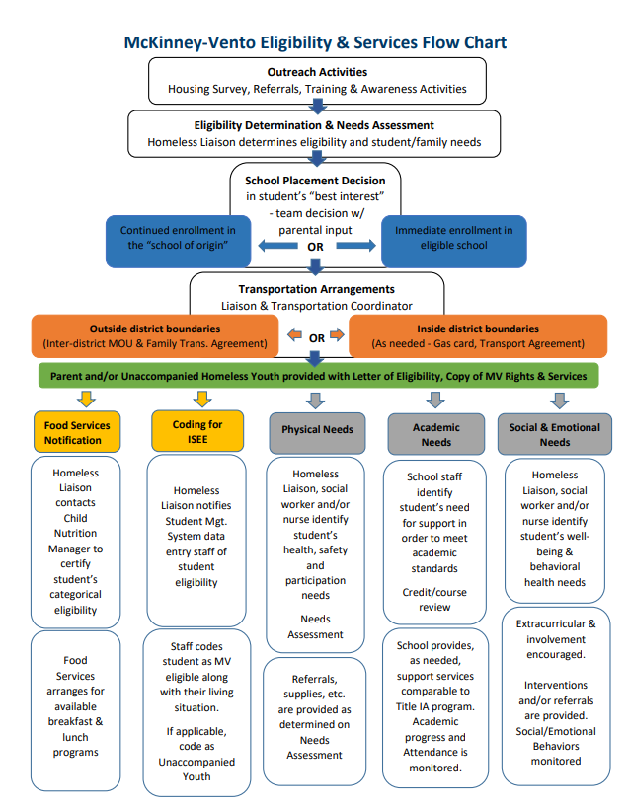

*NOTE: See ASDOE IX-A Homeless Education Website for identification and services flowchart*

## STEP 1: Outreach & Identification

Identifying all students experiencing unstable housing is critical as it allows liaisons to help students and UY who may have difficulty with enrollment, to connect students to educational support and community services, and to increase the likelihood that UHS and UY will overcome the extra educational challenges or barriers they may face.

While it is true that local housing stability liaisons themselves will and should identify many of the UHSs in a school, the actual charge in the law is for local liaisons to ensure that UHSs are identified “by school personnel through outreach and coordination activities with other entities and agencies” [42 U.S.C. § 11432(g)(6)(i)]. The language in the law means two important things. First, local housing stability liaisons are not expected to do the work alone and bear the sole responsibility for identifying students. Second, collaboration with other educational programs and even agencies outside the school is not only encouraged, but it is expected. The collaborations involved in ensuring students in homeless situations are identified may be very informal or be structured around formal activities and relationships.

School staff who may be particularly helpful in meeting the requirement to identify homeless students include

* school nurses;
* front office and registration staff;
* truancy and attendance officers;
* cafeteria staff;
* bus drivers;
* school social workers and counselors;
* classroom teachers and aides; and
* administrators, such as principals or directors of special education and Title IA.

### Strategies to Increase Identification

Awareness Posters -   
Notices regarding the rights of youths experiencing homelessness should be posted in places where parents and youth may see them and must be written in a user-friendly format.

*NOTE: See ASDOE IX-A Homeless Education Website for digital copies and how to order posters, flyers, and postcards in English, Samoan, Tongan, Tagalog, and Cebuano*

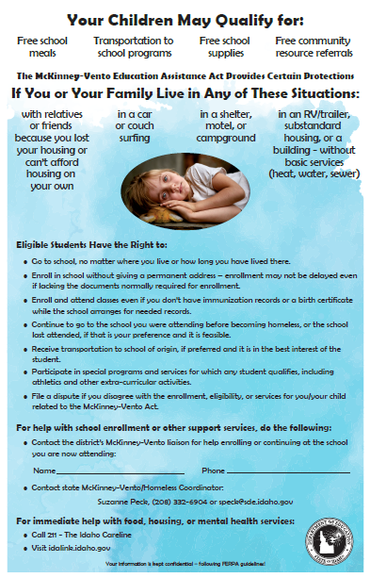

#### Home Survey

Including a housing questionnaire/survey with a simple statement of rights in the general enrollment and registration packet received by all students as they sign up for school is a good way to ensure the entire student population is informed. Avoid using the word “homeless,” as it may be off-putting. By providing the information in all the enrollment packets, no one feels singled out or stigmatized, but even those who are not unstably housed become more aware of the EHCY/Nofoaga le Tumau Program throughout the community.   
***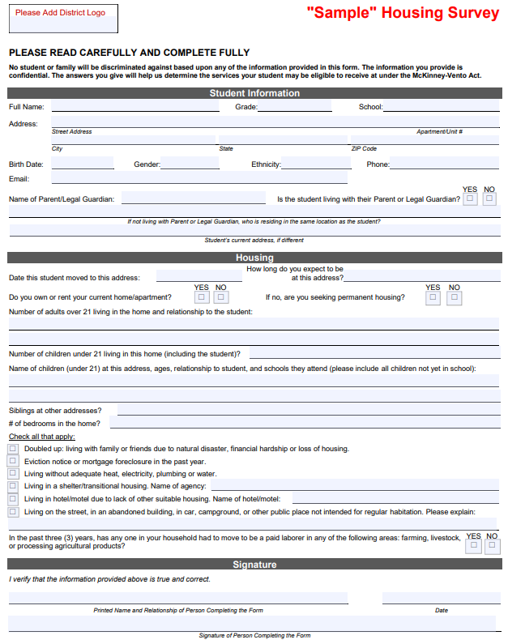****NOTE: See ASDOE IX-A Homeless Education Website for form*

Enrollment & Awareness Events  
As required by statute, **schools must** ***enroll students seeking EHCY/No eligibility immediately***, even if they are unable to provide paperwork normally required for enrollments. Efforts to confirm eligibility should take place once full enrollment has occurred.

Events like New Student Enrollment, Kindergarten Round-up or Head Start enrollment fairs can lead to more identified students. Many communities also host events which focus on connecting persons in need with agencies and organizations that can help them, including schools. Participating in community awareness events can help develop relationships with partners who can help assist the liaison with identification and in meeting the needs of families and students.

#### School Website, Newsletters, and Social Media

The school website should contain the student handbook and other important information for students and their families. It can be a great tool for increasing awareness and disseminating information about the rights of UHSs as well as listing contact information for the liaison.

Mid-Year Outreach  
Families may move from place to place and youth may become estranged from their families after enrolling in school; mid-year identification processes for families to update contact information, for staff to refer students or for youth to self-identify can help connect students to services who were not otherwise identified through beginning of the year enrollment/registration or home questionnaire/survey efforts.

## STEP 2: Verification & Eligibility

To determine a student's EHCY/Nofoaga le Tumau program eligibility, schools must determine whether a student's living arrangement meets the McKinney-Vento definition. In this process, schools will encounter instances where they will want to confirm the information that was provided about a child's or youth's living arrangement.

**Verification/Confirming Eligibility**Completed Housing Survey forms that indicate students are living in potentially “Unstably Housed” qualifying situations will be reviewed in conjunction with the “Eligibility Determination Form” by the school Housing Stability liaison or other school designee for verification of eligibility.

Efforts to confirm information about a child’s or youth’s living arrangement should be respectful, effective, discreet, and maintain school privacy guidelines. Conducting eligibility conversations should be conducted in a private space, in a respectful manner and with care and sensitivity as these conversations are very personal for the family or youth. The local Housing Stability liaison maintains the final authority for making determinations of eligibility. Avoid using the word “homeless” on school forms and in conversation with families or youth. Many families or youth would not want to be called “homeless” due to the stigma that may be associated with the term. Further, families or youth may not consider themselves homeless even though their living arrangement meets the definition.

Once a liaison sensitively and discreetly has explained the rights available under the McKinney-Vento Act, families or youth may choose not to take advantage of McKinney-Vento services at their discretion. The should would still count all children and youth who have been identified as an eligible UHS in their data recording in PowerSchool, even if services are not provided.  
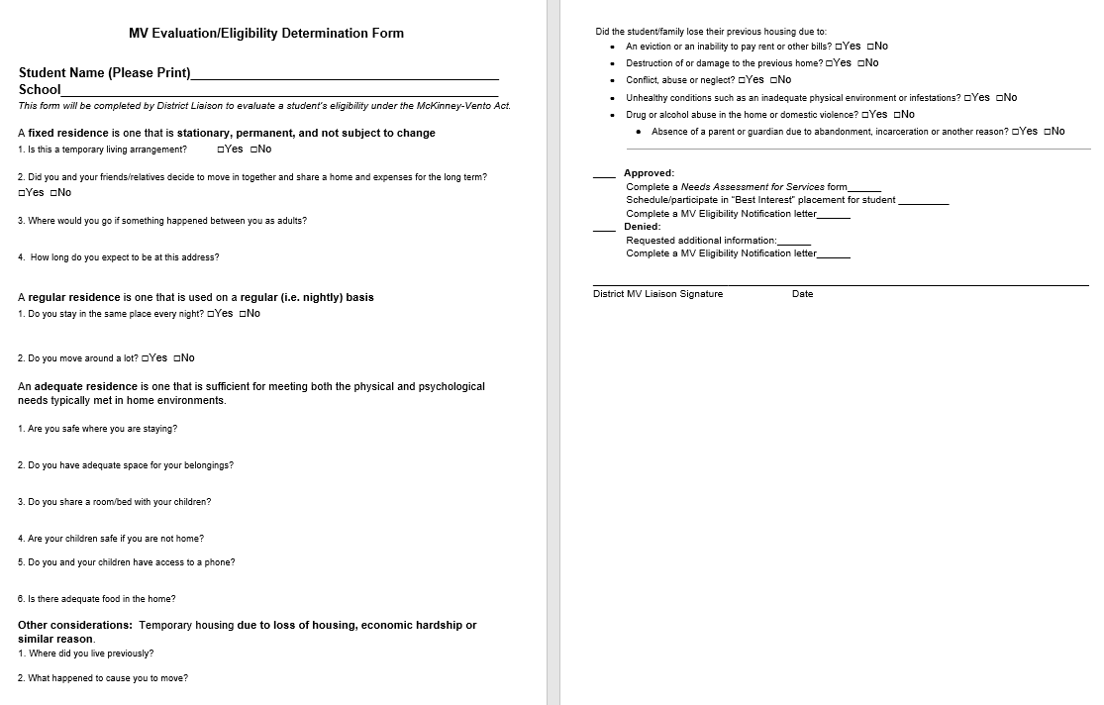  
*NOTE: See ASDOE IX-A Homeless Education Website for form*

**Eligibility Notification**After students have been determined eligible, the liaison will contact the parents of the UHSs and/or the UY to provide them written confirmation of their eligibility or non-eligibility along with a copy of their educational rights under the McKinney-Vento Act.

All students who have been confirmed to be living in a McKinney-Vento situation are eligible for services/supports through the LEA MV/Homeless Education for the remainder of the year.

If, after investigating, a school liaison concludes that a student is not MV eligible, the school must provide the parent/guardian or UY the opportunity to appeal the school’s decision through the ASDOE’s dispute resolution process.

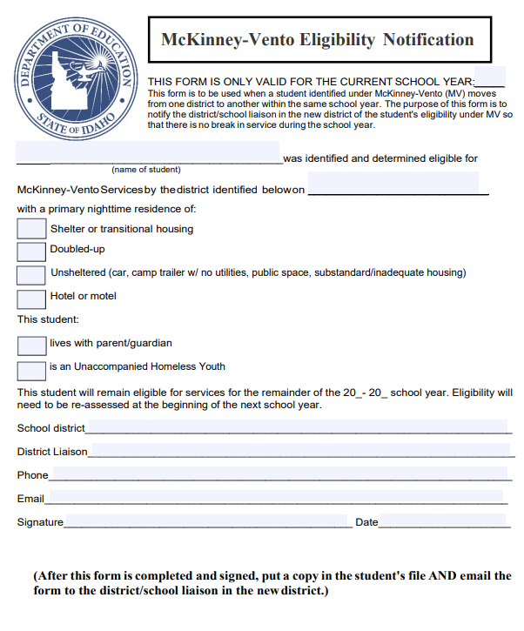  
*NOTE: See Idaho IX-A Homeless Education Website -SID 8 Homeless Educations Services & Identification for “Written Notification of Eligibility Simple Form”*

**Parent Communication**The MVA accords parents and guardians of UHSs the right to have their voices heard on what they believe is in the best interest of their children. The law requires local liaisons to provide parents and guardians information on the MVA and on the process for disputing decisions of the school when they disagree on enrollment and best interest determinations for their children.

Communication is critical for developing trust with parents. Good rapport enables local liaisons to establish a working relationship with parents that results in good educational decisions for children. The following tips will help you develop positive, productive relationships with parents.

* Keep impersonal communication, such as letters and emails, to a minimum; conduct face-to-face conversations whenever possible.
* Provide a welcoming environment.
* Conduct sensitive conversations in a private and comfortable place.
* Avoid using the word “homeless;” avoid charged and judgmental language.
* Talk to them about their living situation; be sensitive and discrete.
* Ask them about their needs. A good question to ask is, “How may we be of assistance to you and your family? What would be helpful for you now?”
* Assure them that their children are welcome in your school and that you have their best interest in mind.
* Empower and encourage parents; discuss solutions to challenges with them.
* Discuss things about which they feel positive.
* Listen! Listen! Listen!

***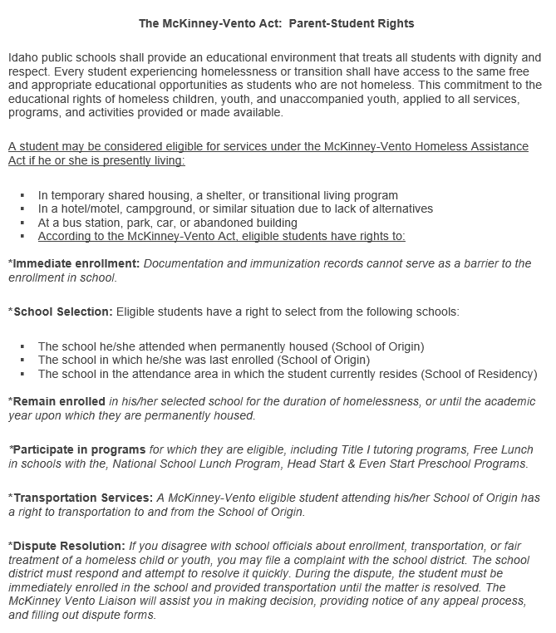****NOTE: See ASDOE IX-A Homeless Education Website for* *copy of MVA Parent-Student Rights*

## STEP 3: Planning & Delivery of Services

The absence of a stable living arrangement has a devastating impact on educational outcomes for youth. For many students who are unstably housed, not having the proper school records often leads to incorrect classroom placement. Medical records, immunization records, previous school transcripts, proof of residency, and for UY, parental permission slips, are some of the “paper” barriers for students being placed efficiently and appropriately within schools.

When students change schools frequently, it is difficult for educators to correctly identify their needs and ensure proper placement. Parents may also have difficulty identifying the difference between academic or social difficulties that result from the stress of instability and high mobility. Also, transportation is an obstacle that often further prevents many homeless children and youth from obtaining education. Stigmas about unstable housing combined with lack of support from the school can often prevent UHSs from receiving the best education possible. All of these reasons prevent UHS and UY from receiving education effectively and efficiently.

The services provided under McKinney-Vento and the EHCY/Nofoaga le Tumau program provide families the opportunity to maintain education stability for their student, which is key to their educational trajectory and success.

One of the priorities of the act is the provision of transportation services to allow students experiencing homelessness to remain in their school of origin, which is defined as the school that the student attended when they first experienced homelessness or the school which they last attended when they were permanently housed.

Students who are identified by the local liaison as meeting the homeless definition are categorically eligible to receive free meals through the Child Nutrition program. To expedite the delivery of nutritional benefits, school child nutrition staff may accept documentation that the UHSs from the local liaison. Documentation to substantiate free meal eligibility must consist of the child’s name or a list of names, effective date(s), and the signature of the local liaison. This documentation is acceptable in lieu of a Free and Reduced-Price Meal Application.

### Needs Assessment

The local liaison will meet with the parent and/or the UHS/UY to determine what services will be provided based on what is available within the school’s EHCY/Nofoaga le Tumau program. The ASDOE organizes supports based on the following types of services needed to remove barriers and to all students to fully participate in their education:

* Basic Needs & Supportive Services
  + Nutritional supports
  + Transportation
  + Social/Emotional counseling
  + Clothing & cold weather needs
  + Etc.
* Academic/Instructional Supports & Services
  + Enrollment assistance
  + School supplies
  + Referral and expedited evaluation for educational support programs
  + Extra-curricular activities
  + Credit recovery and/or Academic Intervention support
  + Graduation supports
  + College/Career counseling & FAFSA support
* Referral Services
  + Community partner resources
  + Medical, Dental & Vision services
  + Department of Health & Welfare navigation program
  + Housing referrals to regional coordinated entry service provider

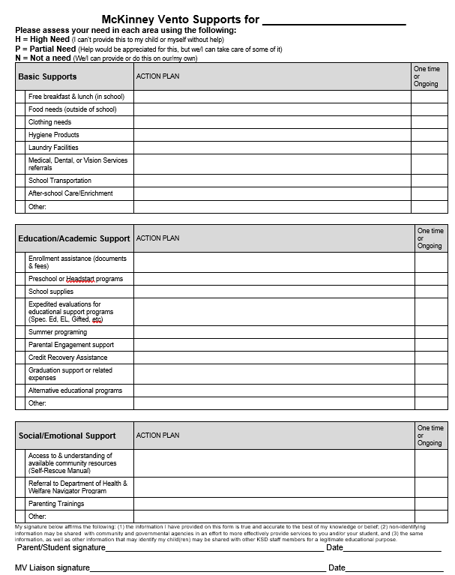

*NOTE: See ASDOE IX-A Homeless Education Website for form.*

## STEP 4: Records & Reporting Processes

Data collection begins at the school level. The local liaison is responsible for working with the school data staff and the ASDOE EHCY/Nofoaga le Tumau Coordinator to ensure accurate data is provided that meets the required elements.

In order to meet the data collection and dissemination requirements in federal law districts are required to collect and provide the identified data to the ASDEE on an annual basis; the ASDEE then submits the information to ED and uses the data for required elements of public reports like state report cards. Data is reported from the schools through the ASDOE Integrated Data System and PowerSchool student management system.

The essential pieces of data that must be submitted by school annually include:

* the number of UHSs enrolled in each grade, including preschool;
* the primary nighttime residence of UHSs enrolled in school;
* the number of UHSs enrolled in school that are a part of particular subgroups, including English learners, unaccompanied youth, students with disabilities, and migratory students;
* the participation and performance of UHSs on statewide reading, math, and science assessments;
* the number of UHSs that dropout or graduate;
* the number of UHSs who are chronically absent; and
* the number of UHSs who are served by Title I, Part A.

# Data Collection & Reporting Tools

## Coding in Student Management System

Identified students should be coded in the school’s Student Management system, PowerSchool, as soon as they are identified to be included in LEA/SEA reporting.

Three pieces of information should be addressed in relation to coding students:

* their EHCY/Nofoaga le Tumau status eligibility;
* one of the 4 eligible unstably housed situations in which they are living -
  1. Primary Nighttime Residence/Living situation - Doubled up (D),
  2. Hotel/Motel (HM),
  3. Emergency Shelter (STH), or
  4. Unsheltered/Substandard Housing (U); and
* If they are experiencing unstable housing without a parent/guardian - Unaccompanied Youth (UY).

## Student MV File & Permanent Records File

A student file should be created and maintained for students deemed eligible for EHCY/Nofoaga le Tumau program supports and services. This record should be kept in a secure location. FERPA protects the privacy of educational records related to unstable housing.

Any record ordinarily kept by the school, including immunization or medical records, academic records, birth certificates, guardianship records, and evaluations for special services or programs, regarding each homeless (UHS) child or youth shall be maintained –

(i.) so that the records are available, in a timely fashion, when a child or youth enters a new school or school district; and   
(ii.) in a manner consistent with section 444 of the General Education Provisions Act (20 U.S.C. 1232g).

The school treats information about a homeless (UHS) child or youth’s living situation as a student education record, and shall not be deemed to be directory information. ESSA Section 722 (g)(D). Personally Identifiable Information (PII) regarding a student’s living situation should only be shared and/or transferred via a secure means.

Contents of the Student EHCY/Nofoaga le Tumau file should include:

* 1. Enrollment and living situation/eligibility documents
  2. Copies of communication/notification with parents or UY
  3. Evidence of processes for data collection and monitoring student well-being, including: attendance, services/referrals provided, academic and/or behavioral supports and credit accrual/progress toward graduation.
  4. Dispute documentation

***~~IMPORTANT! A copy of the written “McKinney-Vento Eligibility Notification” should be filed in the student’s permanent record file for the current year of eligibility. This form must be included when information is sent to another school during a mid-year transfer.~~***

## ASDOEDCI/Program Contact File

The ASDOE District Contact Information system is a district program contact directory used by the SDE look up district/charter school program personnel for communication. Program contact directory information displayed in the ASDOE-DCI application is primarily updated from information/data reported through the ASDOE-SEE Program Contact File submission. The Program Contacts File can be updated at any time with changes taking effect 1-2 business days after the upload.

It is the district responsibility to keep the Homeless Education Program related contacts up to date. To ensure that the correct information is published on the Homeless Education website, please contact the SDE Technology Support desk @ 684 633 2220 or [support@sde.idaho.gov](mailto:support@sde.idaho.gov) for assistance in updating roles.

Role Codes

**McKinney-Vento Liaison (MVL)** – Districts may only assign one individual the role of Title IX-A Homeless/McKinney-Vento Liaison. This individual is the one identified by the district to ensure that the requirements related to the McKinney-Vento Act and the 10 duties of the MV liaison are met. This individual's contact information will be published as the district contact on the Homeless Education webpage.

**Homeless Education Contact (HED)** Districts may have a number of individuals who are working in the Homeless Ed. program assigned the role of Title IX-A Homeless Contact (HED). These individuals will be provided Homeless Ed. Program updates BUT WILL NOT have their contact info listed on the website.

## ASDOE-SEE Uploads

The ASDOE- SDE has created the System for Educational Excellence, a K-12 Longitudinal Data System, which support the budgeting processes, data submission, and delivers information to educational stakeholders to create data-driven decisions. Data reporting is required from the LEA to the SDE through six (6) yearly data submissions. LEAs report data to the SDE for all programs and students.

For more information about dates for ISEE submissions or how to get access to the ISEE portal, please refer to the [ISEE Technology Resource Webpage](http://www.sde.idaho.gov/tech-services/isee/) ([http://www.sde.idaho.gov/tech-services/isee/](http://www.sde.idaho.gov/tech-services/isee/)))

Homelessness data reported at the school level includes:   
• the number of students experiencing homelessness in each grade   
• the type of primary nighttime residence the students had at the time they were identified as homeless   
• the racial/ethnic background of homeless enrolled students   
• the number of students in each subgroup of homeless students   
• the type of primary nighttime residence unaccompanied youth (UY) had at the time they were identified as homeless  
• the number of students served by McKinney-Vento subgrants  
• the number of students served by Title I targeted assistance or schoolwide programs  
• the number of homeless students who were chronically absent  
• the Adjusted Cohort Graduation Rate of homeless students  
• the number of homeless students who complete high school  
• the number of homeless students who drop out of school  
  
Data Submission Timeline & Verification Process  
**IMPORTANT: Local liaisons need to verify data with the district ISEE coordinator BEFORE data is uploaded via ISEE!**

Aug to Sep:   
- Students complete "Housing Survey" at enrollment or registration

-Reverify eligibility for previous MV students

-Verify eligibility for new students

-Coding students: Exit any non-eligible student  
Enter MV status & living situation for each student in the student management system

October:

ISEE upload reflecting only students qualifying for current schoolyear

- all previously identifed students who NO LONGER ELIGIBLE MUST BE EXITED

November:   
ISEE upload reflecting any newly identified students

December:   
ISEE upload reflecting any newly identified students

March:   
ISEE upload reflecting any newly identified students

May:   
ISEE upload reflecting any newly identified students

June:  
ISEE upload reflecting any newly identified students

-Review data in the CFSGA to ensure all identified students are included in the annual report

-Make a note in the CFSGA comments of any increase or decrease in # from previous year of 10% or more

# Funding & Fiscal Responsibilities

Funding Options may include:

* Title IA Homeless Set-Aside
* MV/Homeless Enhancement Subgrant
* Other State Programs
* District Funds
* “Angel Fund”
* Community Partners & Donations

(The following two sections should be personalized by each district/charter)

## Funding Options

* Provide description of what funds are used to support students experiencing homelessness AND how the amount is determined

## Accounting processes

* Provide description of how are funds accessed and accounted for

*NOTE: See ASDOE IX-A Homeless Education Website, Allowable Use of Funds and FA12 - Homeless Education Program Funding for “Homeless Set-Aside & Program Development Needs Assessment”*

# Local Housing Stability Liaison

The local housing stability liaison is the key to ensuring youth living in unstable housing are identified and receive the services related to their unique needs. Every school in America Samoa has the responsibility of naming a local housing stability liaison who to be the primary contact between unstably housed families, school staff, shelter workers, and other service providers. Each school’s liaison contact information is published on the ASDOE Education of Homeless Children and Youth/Nofoaga le Tumau Program website.

The local liaison can fulfill many roles. In carrying out the responsibilities of the position, this person will act as an administrator, a professional development coordinator, a school social worker, and an outreach specialist. Each school will structure the position based on its current needs in serving students who are unstably housed. Furthermore, each school ensures that the liaison will have the sufficient time, training, and capacity to carry out the required set of duties as described in 42 USC §11432(g)(6)(A).

Local Housing Stability liaisons must ensure that:

1. eligible children and youth are identified by school personnel through outreach and coordination with other entities and agencies;
2. eligible children and youth are enrolled, and have a full and equal opportunity to succeed, in school;
3. eligible families, children and youth receive educational services for which they are eligible, including Head Start, early intervention services under Part C (Idaho Infant Toddler Program) of the Individuals with Disabilities Education Act (IDEA), and other preschool programs administered by the LEA;
4. eligible families, children and youth receive referrals to health, dental, mental health, housing, substance abuse, and other appropriate services;
5. parents or guardians are informed of the educational and related opportunities available to their children and are provided with meaningful opportunities to participate in the education of their children;
6. public notice of unstably housed students’ rights is disseminated in locations frequented by parents, guardians and unaccompanied youth, including schools, shelters, libraries and soup kitchens, in an understandable manner and form;
7. enrollment disputes are mediated according to 42 U.S.C. § 11432(g)(3)(E);
8. parents, guardians and unaccompanied youth are informed of and assisted in accessing transportation services, including transportation to the school of origin;
9. school personnel providing McKinney-Vento services receive professional development and other support; and
10. unaccompanied youth are enrolled in school, have opportunities to meet the same challenging state academic standards as other children and youth, including through receiving partial credits, and are informed of their status as independent students for the Free Application for Federal Student Aid (FAFSA) and receive verification of that status.

*NOTE: See ASDOE IX-A Homeless Education Website for a customizable annual School Stability Liaison Calendar*

# MV Policy

The ASDOE ensures that policies and procedures do not create barriers for the education of eligible unstably housed children and youths. American Samoa McKinney-Vento/Homeless policy regarding the education of unstably housed students is regularly reviewed to ensure that the policy meets all of the necessary components.

(Please customize) District policy review process & timeline: _____________________________________

*NOTE: See ASDOE IX-A Homeless Education Website – PROG 31 for a District MV/Homeless Policy Checklist*

# Program Evaluation & Monitoring

Evaluation is a valuable and necessary addition to the provision of services. Built into regular programming, well-conducted evaluations assist providers in knowing if their services have a real impact on families’ lives.  
Standards provide a common basis for establishing measurable goals and implementing a program.

The ASDOE Federal Program Monitoring & Self-Monitoring Tool incorporates the MV related statute from the Every Student Succeeds Act (ESSA) and McKinney-Vento Homeless Assistance Act within the indicators to provide schools a guide to developing the required elements to implement a quality McKinney-Vento - Homeless Education program. The indicators and State monitoring processes are designed to help improve local homeless education program performance and educational outcomes for students experiencing homelessness through a variety of means, including monitoring, technical assistance, and making LEA-level homeless student enrollment and school-level homeless student achievement data publicly available.

## Annual Self-Assessment for Program Improvement

The district/charter reviews program requirements and needs annually in the Spring using the Needs Assessment tool.

Monitoring by the American Samoa Department of Education  
The district/charter participates in the scheduled American Samoa Department of Education – Federal Programs monitoring program. This process may include:

* Uploading evidence via a secure digital application using the Monitoring Upload Tool (MUT) or Idaho Monitoring Application Tool (IMAT)
* Participating in onsite or virtual interviews
* Creating an *Action Plan* based on the *Federal Programs Final Report* to address any findings
* Working with the State MV Coordinator to get approval of program modifications related to the findings in the final report

*NOTE: See ASDOE IX-A Homeless Education Website – Program Development & Monitoring for the current MV/Homeless related indicators*